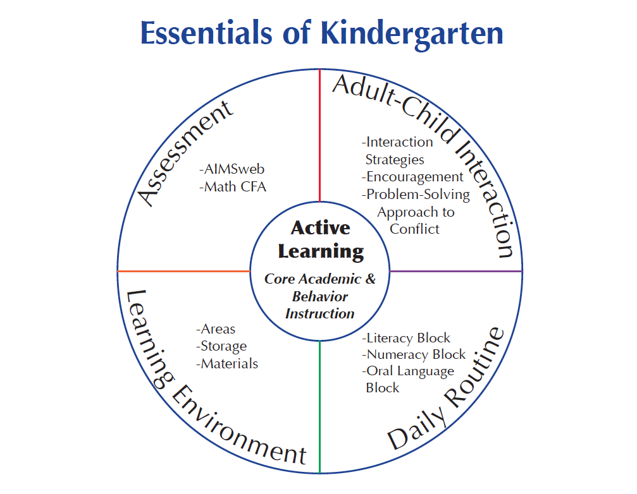Macintosh HD:Users:sheriebert:Desktop:Screen shot 2012-08-23 at 6.10.00 PM.png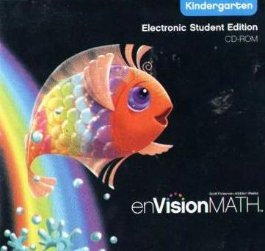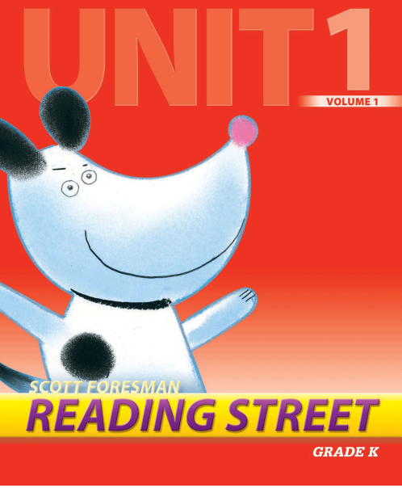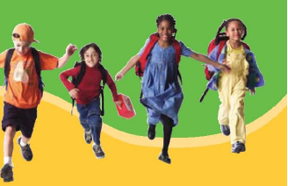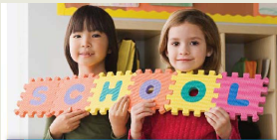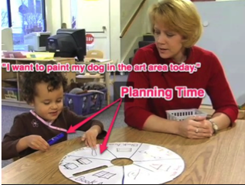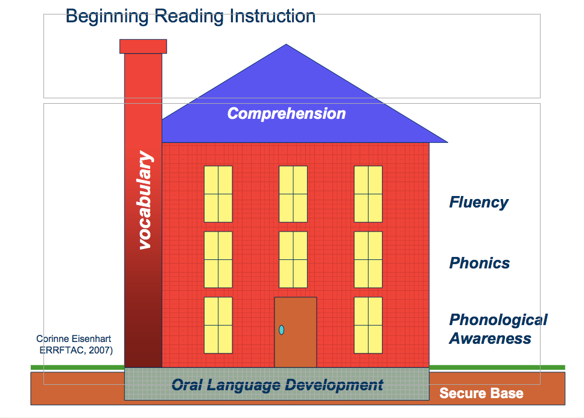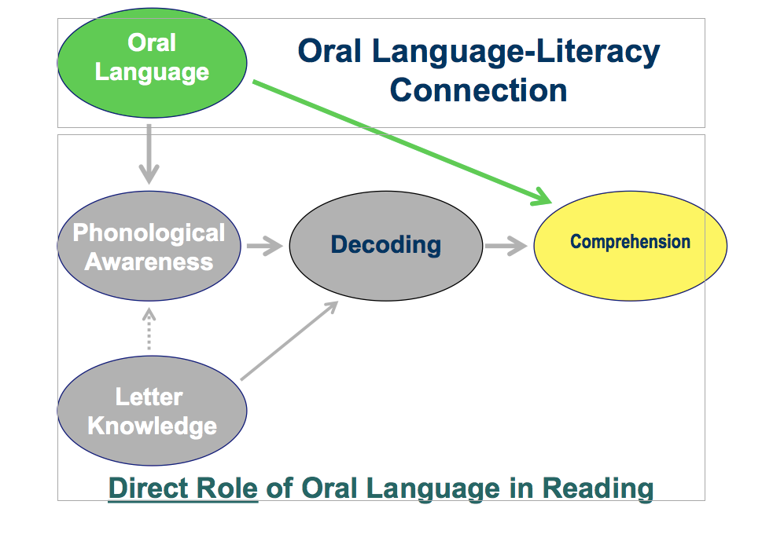

**ORAL LANGUAGE BLOCK**

Kindergarteners use the Plan-Do-Review strategies during the Oral Language Block. They stem from the evidence-based HighScope Research Foundation.

**NUMERACY BLOCK**

Kindergarten students receive differentiated core math instruction from the evidence-based EnVision curriculum during the Numeracy Block.

**LITERACY BLOCK**

Kindergarten students receive excellent core literacy instruction from the evidence-based Reading Street curriculum during the Literacy Block.

**CANYONS SCHOOL DISTRICT**

# **What’s New in Kindergarten?**

**DAILY ROUTINE**

The kindergarten Daily Routine is structured into specific instructional blocks to provide focus and intensity in literacy, numeracy, social/emotional and language skills.

* **LITERACY BLOCK**
* **NUMERACY BLOCK**
* **ORAL LANGUAGE BLOCK**

**The Plan-Do-Review strategies within the oral language block allow students to:**

* Engage with materials and peers through child-driven Plan-Do- Review strategies
* Practice decision-making skills
* Discover their own interests
* Engage fully in what they want to pursue
* Develop creative problem-solving skills
* Practice skills in resolving conflicts
* Develop self-regulation
* Develop trust, empathy and social skills
* Develop communication skills
* Use their creativity and imagination
* Develop skills for critical thinking and leadership
* Analyze and reflect on their experiences
* Extend learning with open-ended materials
* Reduce stress in their everyday lives

**Every gain in oral speech, in knowledge and in vocabulary and in the conventions of formal discourse, that children make in kindergarten or first grade is ultimately a gain in reading comprehension.**

**Hirsch, (2006), p. 29.**

### 

# **More About Oral Language**